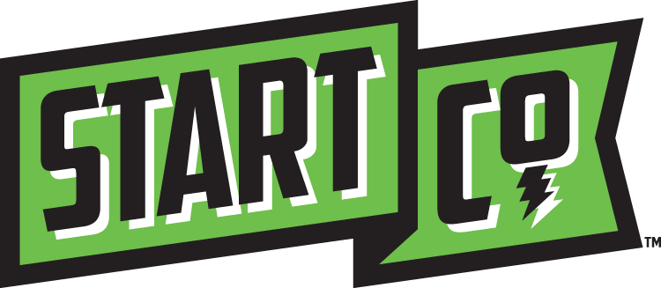

Making a Great Verbal Elevator Pitch
60-90 Seconds Maximum

- Brief, memorable business description without jargon that is 2-4 sentences.
- Who specifically are your customers and what problem are you solving for them
- Offer a real example of how you helped a customer overcome a challenge (pain point) explaining your point(s) of differentiation in the process.
Share a single, vibrant story of how you helped a single customer vs. everything you do to do help all clients. The story should convey your point of differentiation and bring everything to life. Share results.
- What are you asking for? It is important to think about where your business is at in terms of development. Most are not ready for funding so you must ask for something else such as potential customers to gather data from, mentors, connections to resources, a developer, etc.

Example: Start Co. is a non-profit organization that works with ideas and entrepreneurs that have ideas; we accelerate those ideas into startup companies; and surround those companies with an ecosystem of support resources. It is our relentless building of founders and their early stage companies that we feel is the missing ingredient to stimulating Memphis’ economic growth.

Early stage refers to those startups ranging from ideas to companies demonstrating product success. Starting up is very difficult because of the lack of early stage technical assistance; access to quality mentors; connections to seed, validation, and angel funding; and access to resources that can stimulate growth. Start Co. solves this problem through its Start Mentoring, Start Investing, Start Launching, and Start Empowering platforms; where we are mentors, investors, evangelist, and catalysts who do so while being inclusive of the underserved entrepreneurial community in minorities, women, students, and the social sector.

A great example of how we help entrepreneurs is Brit Fitzpatrick who came to one of our startup weekends with just an idea that was chosen and launched. After which she received ad hoc mentorship and was chosen to go through a Start Co. Accelerator program where she received $15,000 and 200 hours of technical assistance. She received post accelerator mentorship further advancing her business where she secured $175,000 through the Start Co. Angels platform, and now she is generating revenues and growing to secure more investment capital.

Start Co. is seeking support in four distinct areas; operational dollars to continue to provide these services free of charge; private investment in the form of seed funding, validation funding, and angel funding; mentors to better assist the startups, and greater storytelling to get more invisible entrepreneurs to take real actionable steps to starting up.

